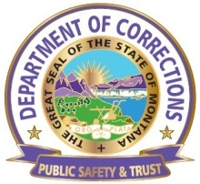
DEPARTMENT OF CORRECTIONS

MONTANA WOMEN’S PRISON

OPERATIONAL PROCEDURE

Procedure No.: MWP 1.3.41a | Subject: EMPLOYEE DRESS, UNIFORMS AND HYGIENE
Reference: DOC Policy No.: 1.3.41 |  | Page 1 of 8 and Attachments
Effective Date: 12/01/1998 |  | Revision Date: 12/15/05, 12/02/2010, 10-28-2014
Signature: //s// Joan Daly Warden

- PURPOSE

To ensure the employees of Montana Women’s Prison (MWP) dress and maintain their appearance in a manner that will promote their personal safety and project a professional and conservative image.

- DEFINITIONS

Non-uniformed Staff - those staff members who are not required to wear a uniform to work.

Uniformed Staff - those staff members who are required to wear a uniform to work. This includes officers, and may also include such areas as infirmary, recreation, food service, etc.

BDU - Battle Dress Uniform

CDOB - Correction/Detention Officer Basic
MLEA - Montana Law Enforcement Academy
MWP - Montana Women’s Prison

- PROCEDURES

- General

  - In the interest of presenting a professional image to the public and serving as a positive role model for inmates and the public, all employees must observe good habits of grooming and personal hygiene.

  - Security Staff may only wear uniform clothing and associated items while on duty and when representing MWP/DOC during authorized functions in the community.

  - All Staff must carry and/or wear their issued MWP ID card in a conspicuous location on their outer clothing at all times while on duty. The ID must be attached to the clothing prior to entering the facility. The ID card must be kept as issued with no alterations.

  - Staff family members may not wear uniforms whole or in part.

  - Security Staff who are on their way to work or returning home from work may not wear their uniform when purchasing alcohol or entering an establishment whose primary function is the sale of alcohol.

  - All Staff must dress professionally and appropriately while on duty. Items not allowed for wear include, but are not limited to:

        - Spandex and/or other form fitting clothing, (exception are undergarments (Under-armor type)).
        - Dirty, wrinkled, worn, ripped, or faded clothing.
        - Shorts.
        - Clothing with designs that are not correctional related/DOC approved.
        - Support/Non-Security staff are allowed to wear sandals and flip flops keeping in mind Business Casual dress this includes women’s open toed dress shoes.
        - Any clothing item, including hats, that isn’t specifically authorized in this procedure.

7. Supervisors are responsible for enforcing appropriate standards of personal appearance and cleanliness of the employees they supervise. Supervisors shall make the final decision as to appropriate dress, grooming, and personal hygiene. If a supervisor determines that an employee’s dress, grooming and personal hygiene or appearance is inappropriate, the employee shall be required to immediately remedy the problem subject to grievance per collective bargaining agreement or DOC policy.
8. Upon termination of employment every staff member must return all state issued equipment and clothing to the designated prison official.
9. Exceptions to the conditions of this procedure may be made on a case-by-case basis to address individual documented medical problems.

10. Hats, if worn, must be the approved black baseball cap (or other approved hat type and color for designated work locations, with the badge design embroidered on the front or a plain solid black stocking cap.

- Clothing

  - Correctional Officers

        - Uniforms will be neat, clean, ironed/wrinkle free, and worn in a manner that presents the image of a correctional professional.
        - Uniform Staff must remain in full uniform (considering exceptions prescribed in operational procedure) for their entire shift.

        - Correctional Officers’ state issued clothing must not be altered by attaching additional badges or insignias, other than those approved by DOC/MWP.

        - The Correctional Officers’ uniform shall consist of State Issued (all state issued clothing will be issued with the appropriate emblems and patches attached):

- Pants – gray – BDU – 6 pockets, also issued are Black Polo shirt (Short Sleeved) (the Polo shirt must be worn tucked in to present a professional image).
- Long sleeve shirt – gray - BDU – 2 pocket with or without epaulettes. Short sleeve BDU’s are acceptable if altered at MCE.
- Black field jacket
- Boots: black; polish able - state issue. Staff with a medical condition that prohibits them from wearing the state issued boot must provide a slip from their medical provider. Supervisors will work with these employees to approve personal footwear that meets their medical needs. Per the bargaining unit agreement, special orders can be made through MCE/MWP for special footwear; tennis shoes will not be acceptable.
- Black baseball cap with approved logo (optional).
- Black nylon duty belt. This duty belt will be worn on the waist and be worn at all times.
- Cuff case.
- Service Pins (5, 10, 15, 20, 25, and 30 year).
- Glove pouch.
- Twenty-inch chain (one).
- Key clips (two).
- Key and equipment chits (as issued in accordance with tool and key control procedures).
- Rapid link (one).
- T-shirt, black, crew neck (solid color, not designs or logos). Under uniform issued per collective bargaining agreement.
- Black MWP polo shirt. Issued per the collective bargaining agreement. The polo shirt will be kept tucked in.

        - Approved non-issued uniform items Correctional Officers or Correctional Counselors: ON A DRESS DOWN DAY when permitted by management.

- Approved black logo short sleeved t-shirts (available for purchase from Montana Correctional Enterprises), under uniform.
- A kaki colored BDU style pants may be worn with a polo style shirt (Must be tucked in with the BDU uniforms (Kaki/grey/black)), with MWP/DOC/MLEA logos on them.
- Black turtlenecks are authorized for wear under the long sleeve uniform shirt.
- Service Sweater - V-Neck black, long sleeve sweater type to be worn over class A uniform shirt.
- Raincoat: black.
- Gloves: black.
- Trouser belt: black.
- Name Tag: silver colored name pin (½” x 2½”), or embroidered cloth strip on black background. The name tag is to be worn on the right side of the shirt, centered on the pocket flap seam.
- Service Stars: two year (silver) or embroidered cloth strip on black background. The service star pins (5-year, 10-year, etc.), service pins are to be worn centered on the right side of the shirt above the name tag location. As these pins are used to designate an officers total years of service, (example an officer with 12 years of service is allowed to wear a 10-year service pin, an officer with 19 years of service is allowed to wear a 15-year service pin)
- Patches, nametags and pins not attached when issued will have the following placements: (see attachment 5)
- Rank insignia pins are to be pinned on the collars of the uniform shirt and field jackets.
- Jeans, if worn must be new in appearance unless assigned to a work detail.
  - Food Service
        - MWP Food Service staff will wear the following clothing which will be issued in the appropriate color with the appropriate emblems and patches attached:
- White Smock.
- Black Jacket/Parka.
- White shirt.
- Black pants.
  - Maintenance Staff:
        - Maintenance staff must wear work clothing that is appropriate for the tasks being performed and must be clearly identifiable as staff members.
- All state issued clothing will be issued with the authorized emblems and patches already attached.
- Approved non-issued uniform items:
a. Shirt - conservative color and style.
b. Pants - conservative color and style.

  - Non-Uniformed Staff:

        - Administrative staff (wardens, administrators, bureau chiefs, directors, unit managers, department heads) must hold themselves to a higher standard to help develop professionalism in their work areas.

        - Non-administrative staff will wear garments that are appropriate to the individual employee’s job assignment/duties, work location, and climate conditions.

        - Employees will use discretion when attending meetings as a representative of the facility. Unscheduled meetings may require a change of clothing, if appropriate.

        - A supervisor may allow an employee to wear more casual clothing on days when the employee is going to be performing tasks that are hard on clothing, such as moving boxes or files, heavy cleaning, conducting searches, etc.

        - Footwear must be appropriate for climate conditions and the employee’s job assignment/duties, work location, and as determined by their supervisor.

  - Athletic shoes for personnel performing duties that involve prolonged standing or walking.
  - Insulated pack-style boots for freezing weather, etc.

        - Skirts must extend below the knee, and skirt slits shall not extend above the knee.

        - Fishnet hose are not allowed

        - Spaghetti straps, backless tops, short shirts, tube tops, tank tops, halter tops, sleeveless tops, or other sheer or revealing dresses or blouses must not be worn.

        - Form fitting pants are not allowed

- Jewelry

  - To ensure compliance with the Department of Health standards established for this industry the only pieces of jewelry Food Service staff may wear while on duty is a simple wedding band and wristwatch. The wristwatch may not be worn when the staff member is involved with direct food production.

  - Staff must not have any jewelry or other items in visual body piercings, i.e. Tongue, nose, eyebrow, lip, etc., with the exception of earrings as outlined below.
- Hair
  - Staff must keep their hair (including male facial hair) neatly trimmed, neatly arranged, clean, and styled to present a professional appearance. Designs, numbers, or initials cut or sculpted into the hair are prohibited.

  - Staff whose duties require them to serve or prepare food must wear a hat and/or hair guard, and beard guard (if applicable) when handling food.

  - Staff must keep their head or facial hair in a manner that allows proper utilization of security/safety equipment (i.e. staff members that may be required to wear a Self-Contained Breathing Apparatus or a Chemical Agents Mask must keep their head and facial hair in a manner that does not prohibit the apparatus or mask from attaining a tight seal).

        - Staff

        - If a hat is worn, the bulk of the hair must not interfere with the proper fit.

        - Staff members whose regular job duties bring them in direct contact with inmates on a daily basis, and who have hair longer than shoulder length, are encouraged to keep their hair in a bun or pulled back in a ponytail.

3. If a hat is worn, the bulk of the hair must not interfere with the proper fit.
4. Any exceptions must have prior approval from the Warden/Associate Warden(s).

- Badges
The Warden will determine who will be issued a badge.
  - Badge awards
- Employees who have completed a minimum of ten years of service may have their badge permanently awarded to them upon termination of employment.
- Employees who want to keep the badge must submit a written request to the Warden/Designee.
- The badge must be affixed to a plaque so that it can no longer be used as a functional badge to individuals who terminate employment, are in good standing with the facility, and have a minimum of ten years of service

2. Procurement and Accounting
a. Badges are ordered from the Warehouse and purchased in accordance with state law, per the instruction of the Warden/Designee.
b. The Associate Warden of Security and/or Associate Warden of Operations will ensure that all state purchased badges are accounted for as; Issued to a current employee; Awarded to a former employee; or in storage.

- CLOSING

Questions concerning this procedure should be directed the Associate Warden of Security and /or Associate Warden of Operations.

- ATTACHMENTS

Attachment 1 – Uniformed Correctional Staff
Attachment 2 - Food Service Staff
Attachment 3 – Optional Dress Uniform for Correctional Staff
Attachment 5c Proper placement for wearing of Badge, Service stars, and name plates
Attachment 7- List of authorized pins that may be worn on the right pocket flap of the lightweight jacket
Attachment 1

UNIFORMED CORRECTIONAL STAFF

Individual uniform items:

- BDU Trousers/ Gray
  - Will be neat, cleaned, pressed and if worn bloused will follow the blousing requirements outlined in this policy/procedure. They must be worn with an 8-inch or higher boot. When bloused, it is above the top of the boot in a typical military fashion. (attachment 6)
- BDU Blouse/Gray:
  - Will be neat, cleaned, pressed and worn either tucked in to the waistband or left out.
  - Initial sewing on of MWP patches, nametags, service stars and badges will be done through the Inmate Services Supervisor at states expense. Any other alterations will be at the officer’s own expense. Shirts may be made into short sleeve shirt through the Inmate Service Supervisor and at the owner’s expense.
  - The sleeves may be rolled up in a “Chem. Roll” or all the way down and buttoned.
  - All buttons on the uniform will be buttoned down.
  - MWP patches will be placed on both sleeves, centered and 1 inch below the epaulet.
  - Cloth badges will be sewn or embroidered 1 inch above the left breast pocket flap and centered.
  - Gray cloth nametags with gold ¾ inch letters will be sewn above, centered and resting on the right breast pocket flap.
  - Silver service stars will be sewn ¼ inch above the letters of the nametag and centered.
  - Metal chevrons will be worn on the collars. They will be centered, with the bottom points of each chevron on the collar seam, (attachment 5). Lieutenant bars will be worn parallel to the collar, ½ inch up and centered, (attachment 5).
  - Metal FTO emblems will be worn on the left collar in lieu of the metal chevron. They will be placed diagonally on the collar. Each point of the emblem will be touching the seam of the collar, with each point of the emblem equidistant from the point of the collar. (attachment 5)
  - Black ICP patch with gold letters will be sewn and centered on the right breast pocket of Correctional Officers in the ICP.
  - State ID’s will be clipped on either epaulet.
  - Pockets will not be filled with any item that precludes it from properly closing. Two pens in the left packet of the shirt are acceptable.
- T-shirts:
  - Black crew neck/turtle neck, solid color with not logos or designs. No white t-shirts
- Service sweater (optional from 15 October to 15 April)
  - Purchased through the Inmate Services Supervisor at owner’s expense.
  - Black crew neck or “V” neck, no buttons or cardigans
  - May be worn over BDU shirt with the collars of the shirt on the outside with metal chevrons on the collars.
- Vest, black quilted nylon with zipper:
  - Purchased through the Uniform Supervisor at owner’s expense
  - May be worn over either uniform shirt while outdoors.
- Windbreaker and liner
  - State issue, black
  - MWP patches will be placed on the sleeves, centered and 1-½ inches below the seam.
  - Badges may be worn if badge tab is attached to windbreaker.
  - DOC pins, state longevity pins and other authorized pins may be worn on the right pocket flap of the jacket only. They will not be worn on any other uniform item. See attachment 7 for a list of approved pins.
  - May not be worn with civilian clothes.
- Winter parka and hood:
  - State issue, black
  - MWP patches will be placed on the sleeves, centered and 1-½ inches below the imaginary seam.
  - Badges may be worn if badge tab is attached to parka
  - May not be worn with civilian clothes.
- Footwear:
  - Must be black, 8 inch or higher duty boots. Should be comfortable and functional with good traction and support. Leather footwear shall be kept will blackened and polished
- Hats:
  - Black baseball cap with MWP insignia.
  - May be worn while working outdoors, on transport, or when indoors with duty belt on.
- Gloves:
  - Black.
  - May be worn while working outdoors or on transport, not to be worn indoors at MWP.
  - One silver bar – Will be worn by the Correctional Lieutenants.
  - Cloth silver in color stars will be worn to designate longevity. One star for each five (5) years of state service.
  - The three-inch (3”) MLEA patch may be worn over the right pocket of the jacket, centered between the pocket and the epaulet by those persons who have successfully completed MLEA.
- Duty belts:
  - MWP furnished black nylon 2 inch wide.
  - Minimum gear to be worn on the duty belt as per the procedure order pertaining to Uniform Security Equipment:
    - Case and handcuffs furnished by MWP.
    - Glove pouch furnished by MWP
    - Radio and radio pouch furnished by MWP.
    - Keys, key chain, and chits furnished by MWP.

  - Optional equipment for the for the duty belt:
    - Key ring holder of same material as duty belt.
    - Black only, mini mag style, flashlight and flashlight holder.
  - Personal duty belts may be purchased at no expense to MWP and need to be black in color nylon, vinyl or leather (plain, basket weave, or clarino), and be 2 to 2 ¼ inches wide. Belt keepers of the same material as the belt may also be worn and purchases at no expense to MWP.
- Trouser belts:
  - 1 to 1 ¾ inch wide black nylon, leather, basket weave, plain, or high gloss. Trouser belts will be worn whenever the duty belt in not worn.

Attachment 2

FOOD SERVICE STAFF
Individual uniform items:
- Black Trousers
  - Will be neat, cleaned and pressed.
  - Initial hemming of the trousers can be done through the Inmate Service Supervisor at MWP’s expense. Any other alterations will be at the officer’s own expense.
  - Hems will be within ½ inch of the junction of the heel and sole and will be 7/8 inch shorter at the front. (attachment 6)
- White shirt with black epaulets and black pocket flaps:
  - Will be neat, cleaned, pressed and worn tucked in to the waistband. Initial sewing on of MWP patches will be done through the Inmate Services Supervisor at states expense. Any other alterations will be at the officer’s own expense.
  - All buttons on the uniform will be buttoned down.
  - MWP patches will be placed on both sleeves, centered and 1 inch below the epaulet.
  - Silver metal nametags will be worn above, centered and resting on the right breast pocket flap.
  - Silver metal service stars will be worn ¼ inch above the metal nametag and centered.
  - Metal chevrons will be worn on the collars. They will be centered and with bottom points of the chevron resting on the seam of the collar. (attachment 5)
  - MWP silver metal collar pins will be worn by the Food Service Director in lieu of rank insignia. The insignia will be worn in the same manner as the FTO insignia. (attachment 5)
  - State ID’s will be clipped on either epaulet.
  - Pockets will not be filled with any item that precludes it from properly closing. Two pens in the left packet of the shirt are acceptable.
- T-shirts:
  - White crew neck, solid color with not logos or designs.
- Vest, black quilted nylon with zipper:
  - Purchased through the Uniform Supervisor at owner’s expense
  - May be worn over either uniform shirt while outdoors.
- Windbreaker and liner
  - State issue, black
  - MWP patches will be placed on the sleeves, centered and 1-½ inches below the seam.
  - DOC pins, state longevity pins and other authorized pins may be worn on the right pocket flap of the jacket only. They will not be worn on any other uniform item. See attachment 7 for a list of approved pins.
  - May not be worn with civilian clothes.
- Winter parka and hood
  - State issue, black
  - MWP patches will be placed on the sleeves, centered and 1-½ inches below the imaginary seam.
  - May not be worn with civilian clothes.

- Footwear:
  - Must be black polish able oxfords, dress boots, duty boots, or black athletic shoes. Should be comfortable and functional with good traction and support.
  - High-heels, clogs, sandals, or platform footwear are not allowed.
  - Leather footwear shall be kept will blackened and polished, while canvas and other materials will be kept clean and well blackened.
- Hats:
  - Black baseball cap with MWP insignia.
  - Must be worn while working on the serving line.
- Gloves:
  - Black.
  - May be worn while working outdoors or in the coolers.
- Chevrons:
  - MWP furnished silver metal chevrons. One set per Food Service Supervisor.
  - Silver chevron - Three stripes - will be worn by the Food Service Supervisors.
  - Silver metal stars will be worn to designate longevity. One star for each five (5) years of state service.
- Trouser belts:
  - 1 to 1 ¾ inch wide black nylon, leather, basket weave, plain, or high gloss.

Attachment 3

OPTIONAL DRESS UNIFORM

CORRECTIONAL STAFF

(Purchased by the individual)
Individual uniform items

- Trousers, gray with black stripe.
  - Hemming of the trousers will be at the officer’s expense.
  - Hems will be within ½ inch of the junction of the heel and sole and will be 7/8 inch shorter at the front. (attachment 6)
  - Will be neat, cleaned and pressed
  - All buttons will be buttoned.
- Shirt, gray with black epaulets and black pocket flaps, either long sleeved or short sleeved
  - MWP patches can be sewn on by the MCE at the Officers expense. Any other alterations will be at the officer’s expense.
  - MWP patches will be placed on the sleeves, centered and 1 inch below the epaulet unless it is a female shirt with the extra short sleeves then it will be centered and only ½ inch below the epaulet.
  - State ID’s will be clipped on either epaulet.
  - Silver metal nameplates will be worn, centered and resting on the top edge of the right pocket flap.
  - Service metal stars will be worn, centered and ¼ inch above the silver nameplate.
  - Metal badge, issued by state, will be worn on the badge tab over the left breast pocket.
  - Pockets will not be filled with any item that precludes it from properly closing. Two pens in the left packet of the shirt are acceptable.
  - All buttons will be buttoned.
  - Black clip on tie may be worn with the long sleeve shirt.
  - Metal rank insignia will be worn on the collars. They will be centered, with the bottom points of each chevron on the collar seam, (attachment 6). Lieutenant bars will be worn parallel to the collar, ½ inch up and centered, (attachment 5)
- T-shirts:
  - Black crew neck/turtle neck, solid color with not logos or designs. No white t-shirts.
- Badges may be worn if badge tab is attached to parka
- Footwear:
  - Must be black polish able oxfords, dress boots, duty boots, or black athletic shoes. Should be comfortable and functional with good traction and support.
  - High-heels, clogs, sandals, or platform footwear are not allowed. Leather footwear shall be kept will blackened and polished, while canvas and other materials will be kept clean and well blackened.

- Socks:
  - Black or dark blue if they are visible when worn with the gray uniform.
  - Specials socks that are white cotton on the bottom and black on the top may be purchases through the Uniform Supervisor.
- Hats:
  - Black
  - Baseball cap with MWP insignia.
  - May be worn while working outdoors or on transport, not to be worn indoors at MWP.
- Gloves:
  - Black.
  - May be worn while working outdoors or on transport, not to be worn indoors at MWP.
- Trouser belts:
  - 1 to 1 ¾ inch wide black nylon, leather, basket weave, plain, or high gloss.

  - 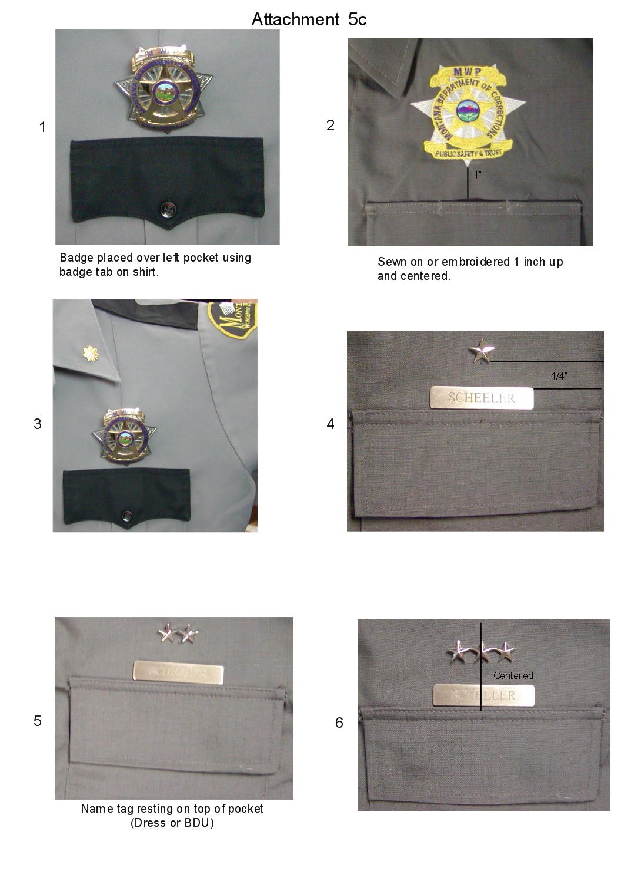

Attachment 6
List of authorized Pins
LIMIT OF FOUR PINS

State or Department Issued (examples--State of Montana Service Longevity pin or Award)
Montana Corrections Association Pins
MLEA pins
Small American Flag Pin (no more than 3/4 to 1 inch in length)
Other Awards as approved by Warden or designee

